Hapi

Mostafa Farrag

2. Installation 3
2.1. Create an Environment 3
2.2. Install Required packages 4
1.1.1. Numpy 4
1.1.2. Pandas 5
1.1.3. Scipy 6
1.1.4. Gdal 7
1.1.5. Shapely 10
1.1.6. Geopandas 10
1.1.7. Fiona 12
1.1.8. Pyopt 13
1. Heading 1. 14
1.1. Heading 2 14

List of Figures

List of Tables

Installation

Create an Environment
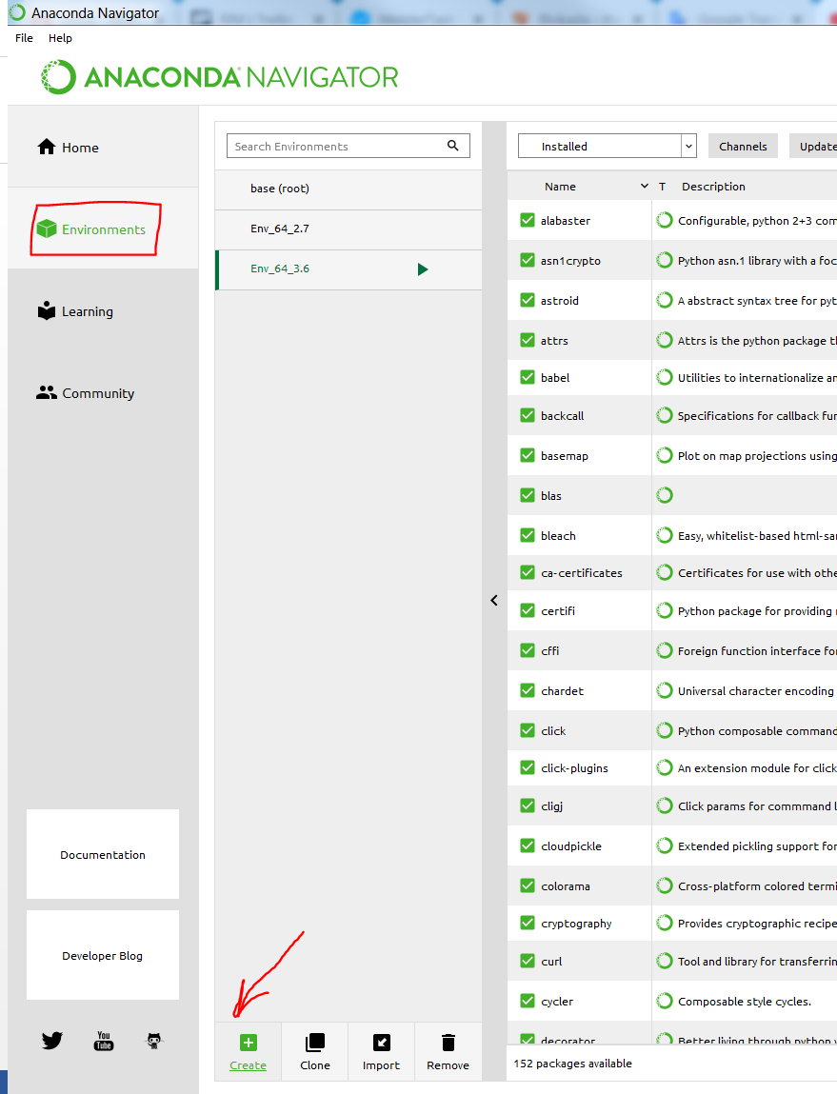
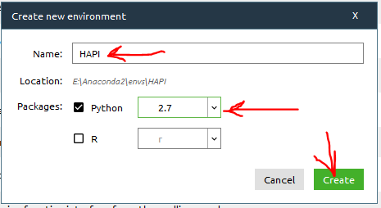

Install Required packages
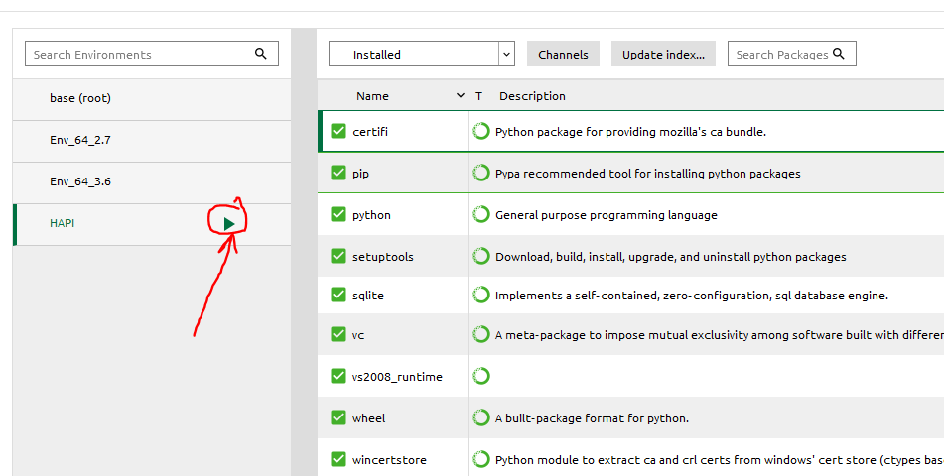

Numpy
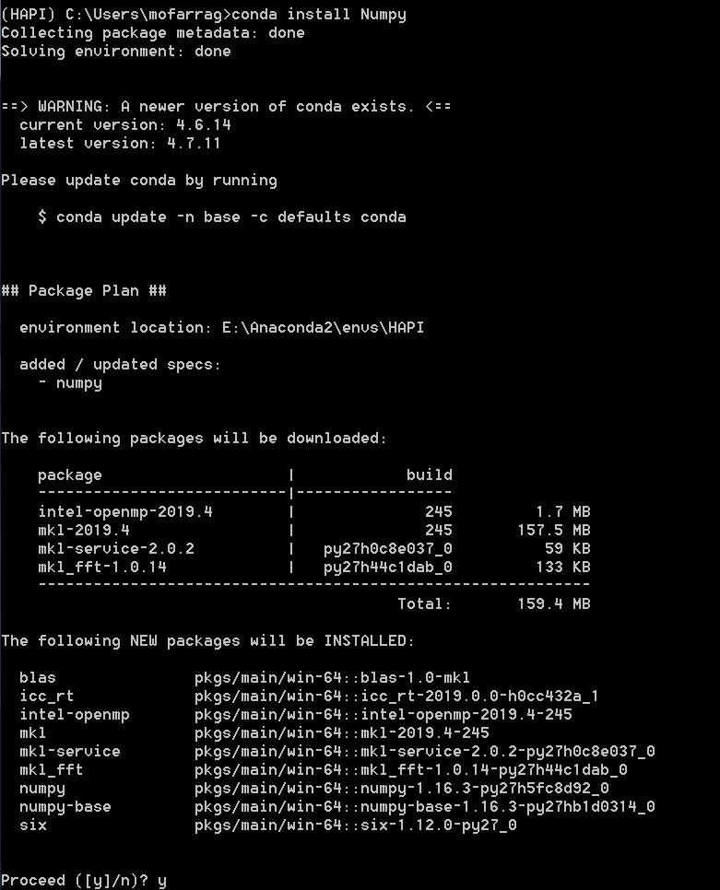
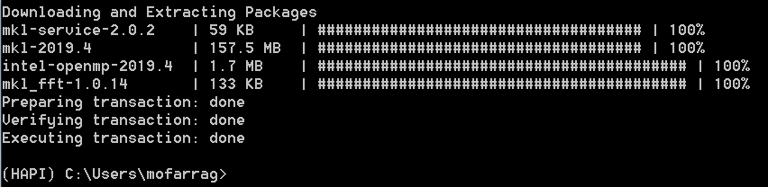

Pandas
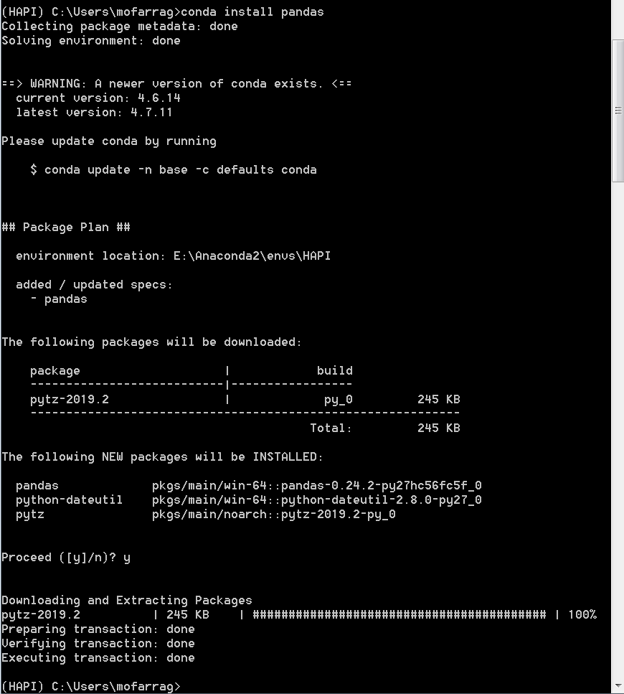

Scipy
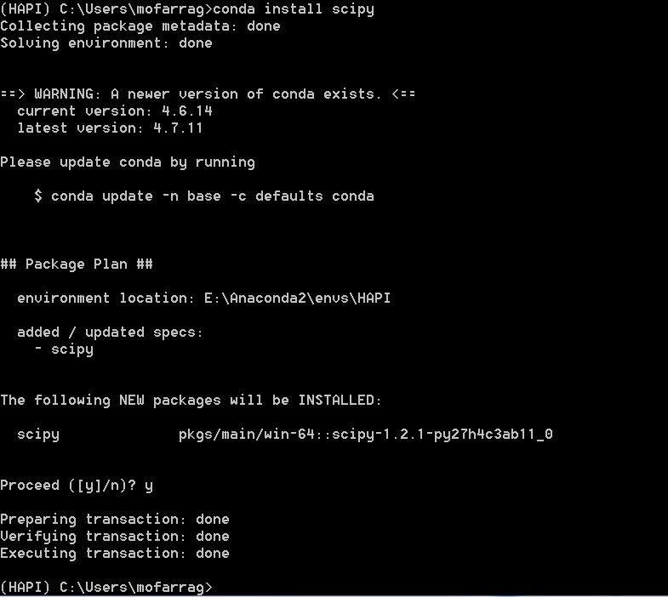

Gdal
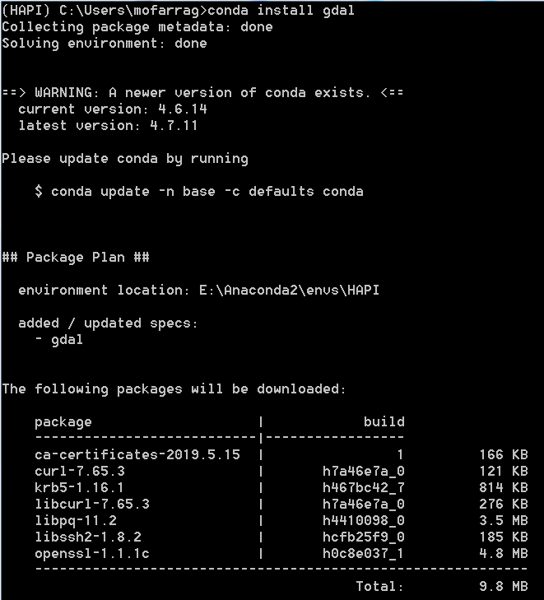
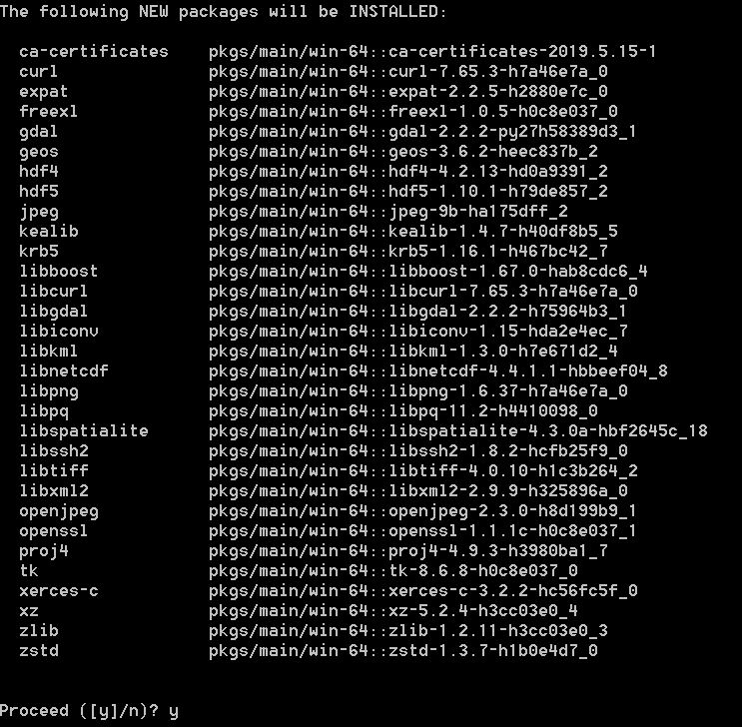
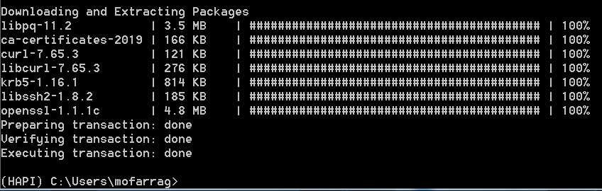

Shapely
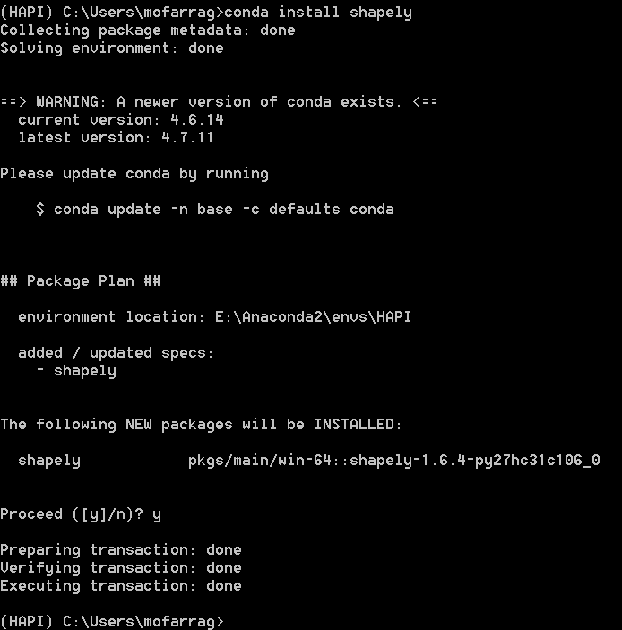

Geopandas
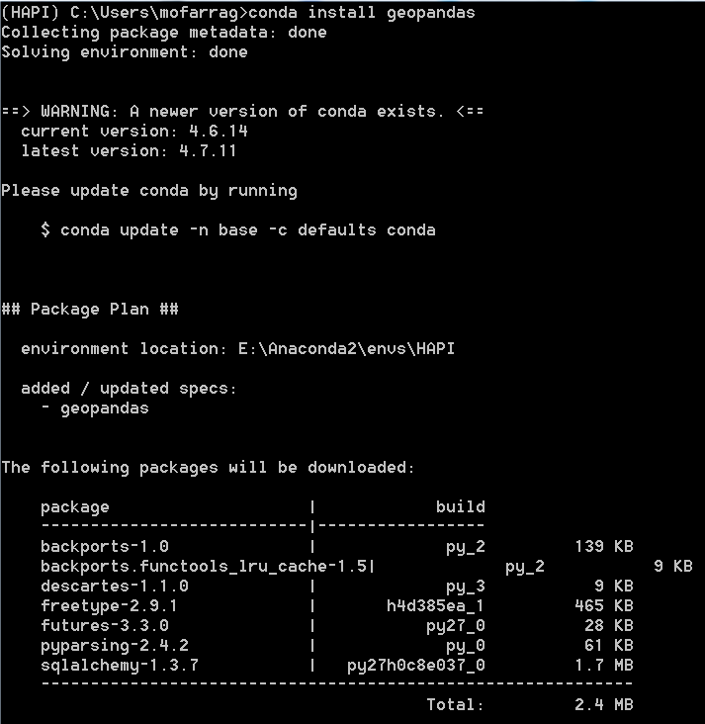
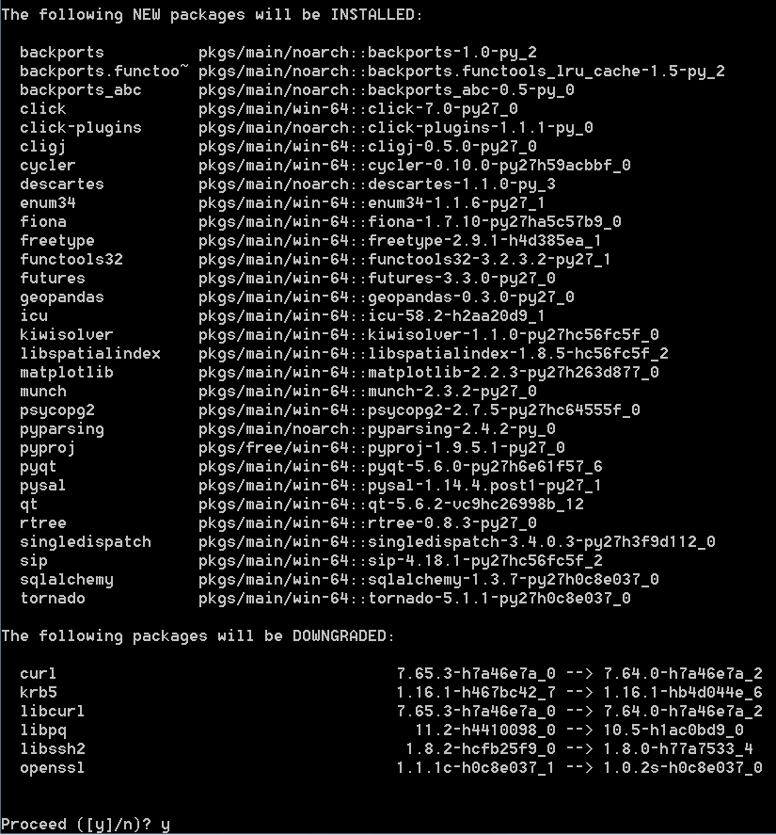
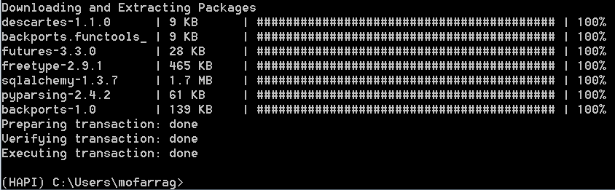

Fiona
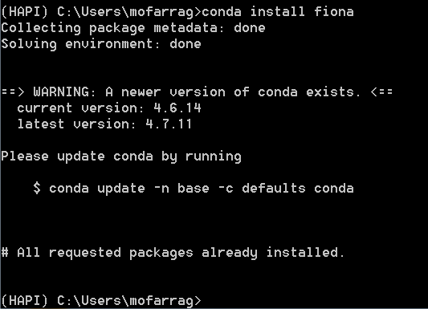

Pyopt
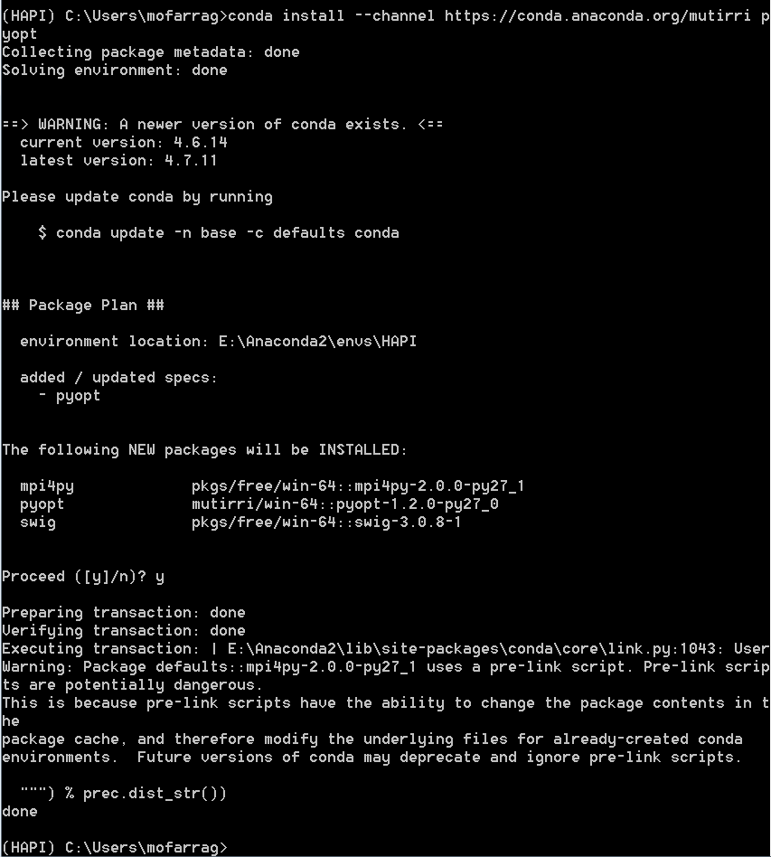

Installing Hapi

Getting the path to your Python
First get the path to your environment then inside the folder of the emvironment you will find “python.exe”
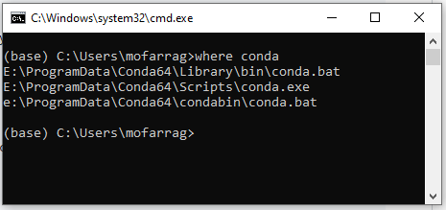
Then open command prompt and change the directory to the folder where you cloned Hapi Library
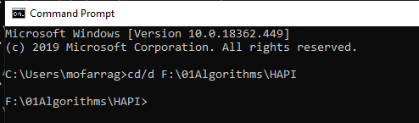
Then type
Path where python exist\python setup.py install
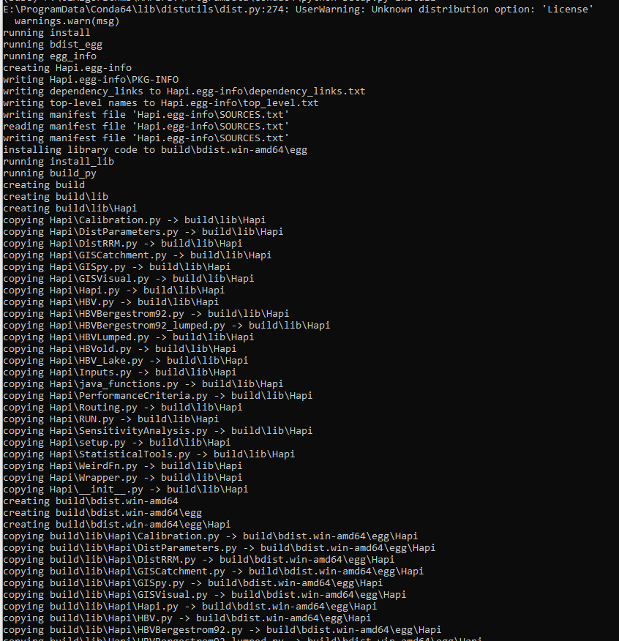

For Python2.7
The compiled files will appear inside the library folder in the site-packages path inside the environment

For Python 3.7
Still error

